

Team Inventory

September 21, 2017

**Sponsor:**

Dr. Benjamin L. Ruddell

**Team Mentor:**

Dr. Eck Doerry

**Team Members:**

Luis Arroyo

Logan Brewer

Ryan Ladwig

Kelli Ruddy

**Overview**

The purpose of this team inventory document is to briefly introduce the members of our team. The following pages briefly outline the training, skills, and relevant experience of each team member.

**Luis Arroyo** 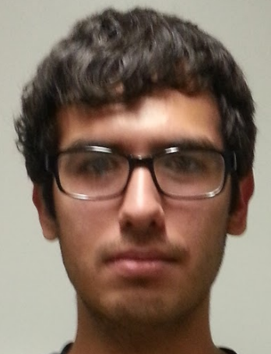

Major: Applied Computer Science

Hometown: San Luis, AZ

**Education:**

High School: San Luis High School

High School GPA: 3.8

Institutions studied at: Arizona Western College, Northern Arizona University

300+ level courses: CS 301 Computers and Society, CS 345 Principles of Database Systems, CS 386 Software Engineering, CS 480 Operating Systems, ENG 302W Technical Writing.

**Work Experience:**

* Database Grader
  + Currently grading for CS 345 students and assist students if they have questions on homework and projects.

**Skills:**

* Database
  + Took classes in CS 345 Principles of Database Systems, which covered ER Diagrams, basic SQL coding, and write triggers and procedures.
* Web Programming
  + Took classes in CS 212 Web Programming, which covered the basics of how web pages functioned. Also learned basic programming languages, which are CSS, PHP, MySQL, JavaScript, and XML.

**Other Interests:**

During my spare time, I enjoy playing video games and playing drums. I also enjoy running around Flagstaff and exploring new places. When I graduate from NAU, I want to work in a job that relates with Databases or Web Development.

**Logan Brewer**

Major: Applied Computer Science

Hometown: Surprise, Arizona

**Education:**

High School: Valley Vista High School

High School GPA: 3.83

Institutions studied at: Northern Arizona University

300+ level courses: STA 371 Intermediate Statistics, ENG 302W Technical Writing, CS 399 Mobile Application Development, CS 301 Computers and Society, CS 345 Principles of Database Systems, CS 386 Software Engineering, CS 480 Operating Systems.

**Work Experience:**

* None relevant

**Skills:**

* Analyzing and determining significance of statistics
  + Took STA 371 which went in depth on how to analyze statistics and how to draw conclusions from that information.
* Working with android mobile apps
  + Took CS 399 which went over how to develop a mobile app, as well as how to make it have a good UI.
* Understanding of the whole software development process
  + Took CS 386 which went through the full process of developing software from the start to the finish.

**Other Interests:**

Things that I am interested in include video games and video game development, as well as most smart phone apps. These are all things very relevant in today’s society and knowing about them is something that I enjoy.

**Ryan Ladwig** 

Major: Computer Science, Modern Languages (German Emphasis)

Hometown: Tempe, AZ

**Education:**

High School: Marcos de Niza High School

High School GPA: 3.2

Institutions studied at: Northern Arizona University, Dortmund Technische Universität

300+ level courses: ENG 302W Technical Writing, CS 345: Principles of Database Systems, CS 386: Software Engineering,CS 413: Virtual Worlds, GER 303: Intermediate Grammar and Composition, GER 304W: Intermediate Grammar and Composition, GER 408: Field Work Experience

**Work Experience:**

* Intern at Technische Universität Dortmund with the Department of Algorithm Engineering (5 Months)
  + Implemented graph isomorphism algorithms in Python and tested them on large datasets.
  + Managed the tools and software on my Linux workstation
* Student Technician and the NAU Student Technology Center
  + Introduced to the Linux command line

**Skills:**

* Web Development
  + Designed a website with a simple login system in CS 212: Web Programming
  + Designed a simple online game in CS 386: Software Engineering
  + Developed games in Javascript in CS 413: Virtual Worlds
* Databases
  + Designed a simple relational database in CS345: Principles of Database Systems
  + Used a database to store persistent game sessions in CS 386

**Other Interests:**

I first chose to major in Computer Science because I grew up playing video games with my brother. Growing up my father, brother, and I spent time together fishing and hiking in the deserts of Arizona, and I still enjoy fishing whenever I can.

**Kelli Ruddy** 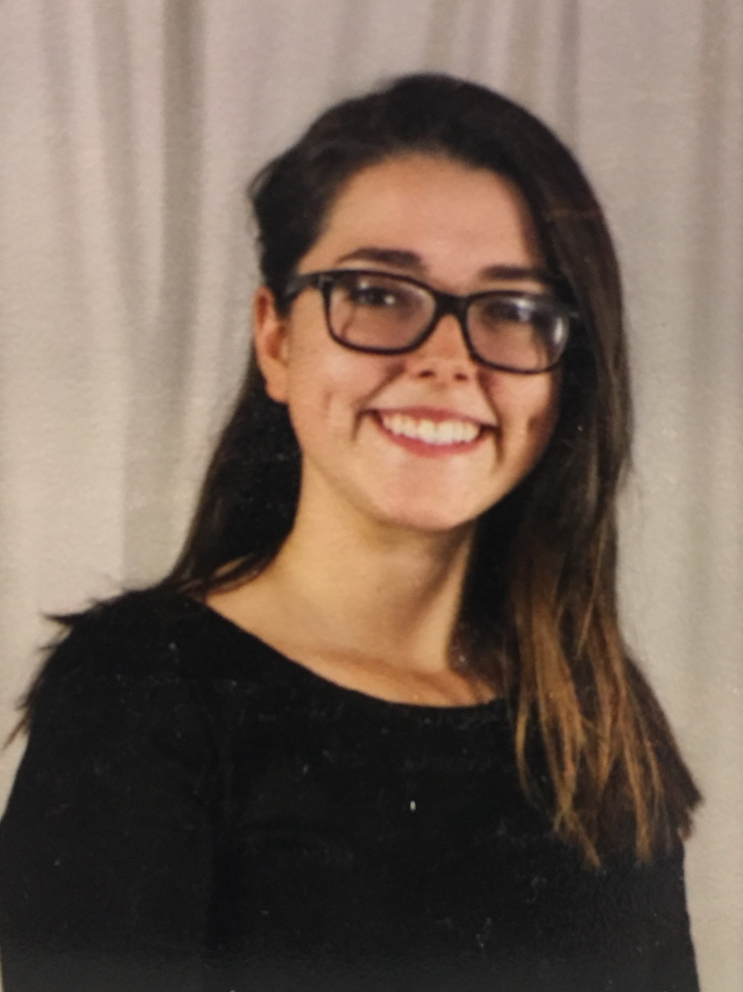

Major: Computer Science

Hometown: Las Vegas, NV

**Education:**

High School: Bishop Gorman High School

High School GPA: 3.3

Institutions studied at: Northern Arizona University

300+ level courses: CS 301: Computers and Society, ENG 302W Technical Writing, CS 345: Principles of Database Systems, CS 386: Software Engineering,CS 399: Mobile Application Development, CS 480: Operating Systems

**Work Experience:**

* Lab Aide and teaching assistant for CS 122: Programming for Engineering and Science(MATLAB)

**Skills:**

* Developing mobile applications
  + Took a mobile applications class and semester project for CS 386: Software Engineering was a mobile application.
* Web Development
  + In CS 212, Web Development, I made a simple website to allow messaging and sign ins.
* Design Process
  + Through CS 386: Software Engineering I learned a lot about the importance of the design process.

**Other Interests:**

I am extremely passionate about giving back and creating things to help better the lives of others. I also spend a lot of time outdoors doing things like hiking and running.